- In order to track your new TPN, Click on TPN Search

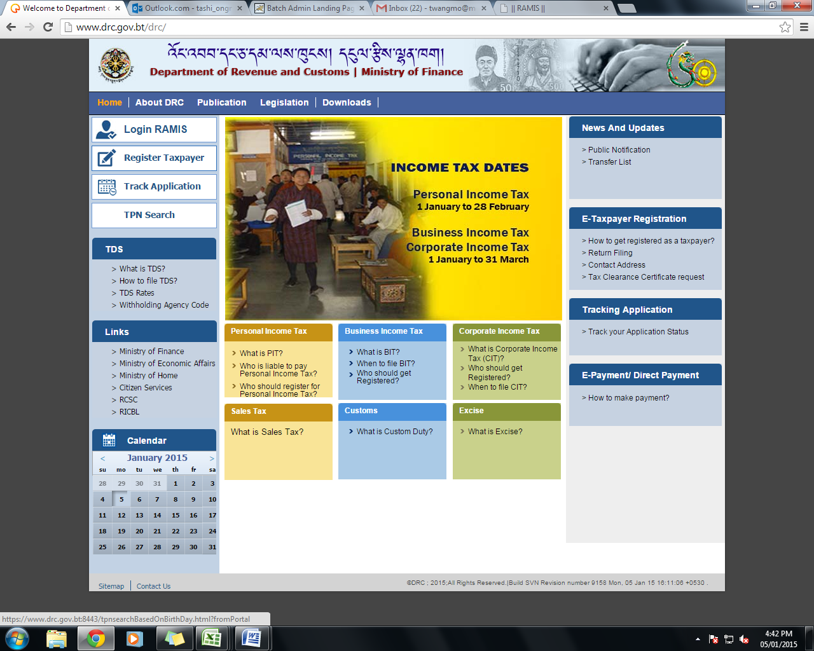

- Enter your CID no. and Date of Birth and click on Submit. Your TPN and Name will display.
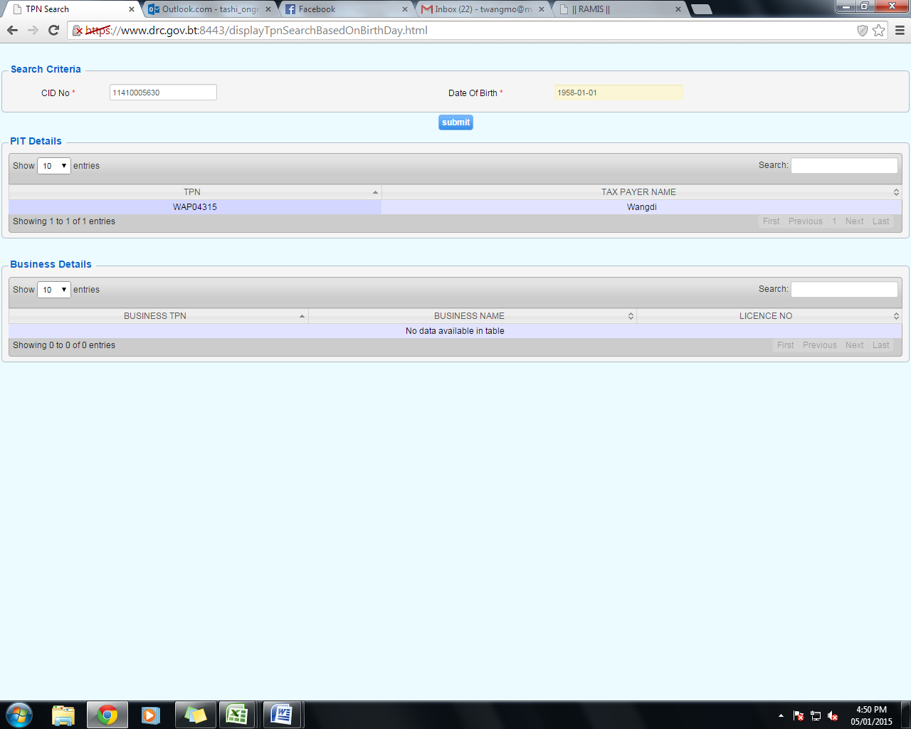

- To login to RAMIS, click on login RAMIS.

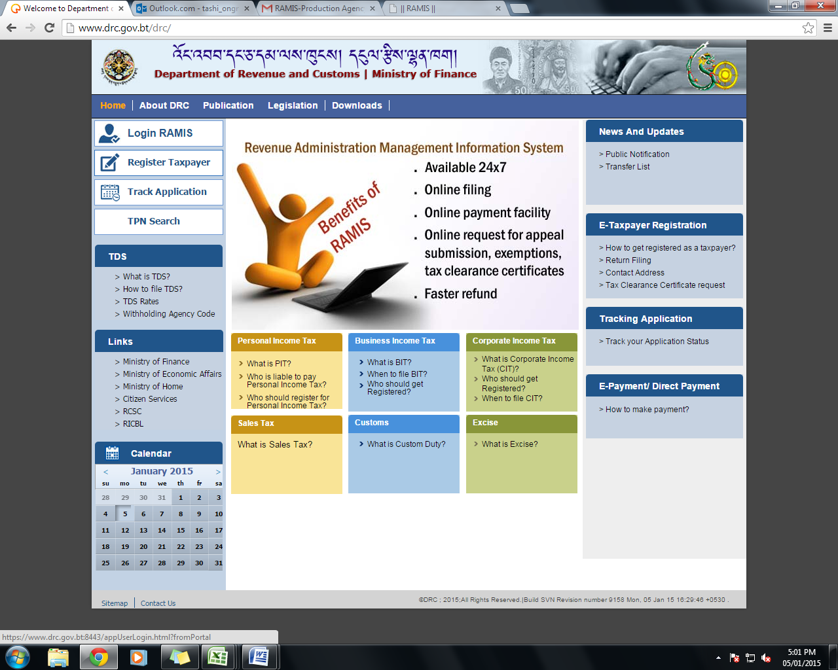

- Login User ID and Password is the new TPN. However, you need to change the password immediately.
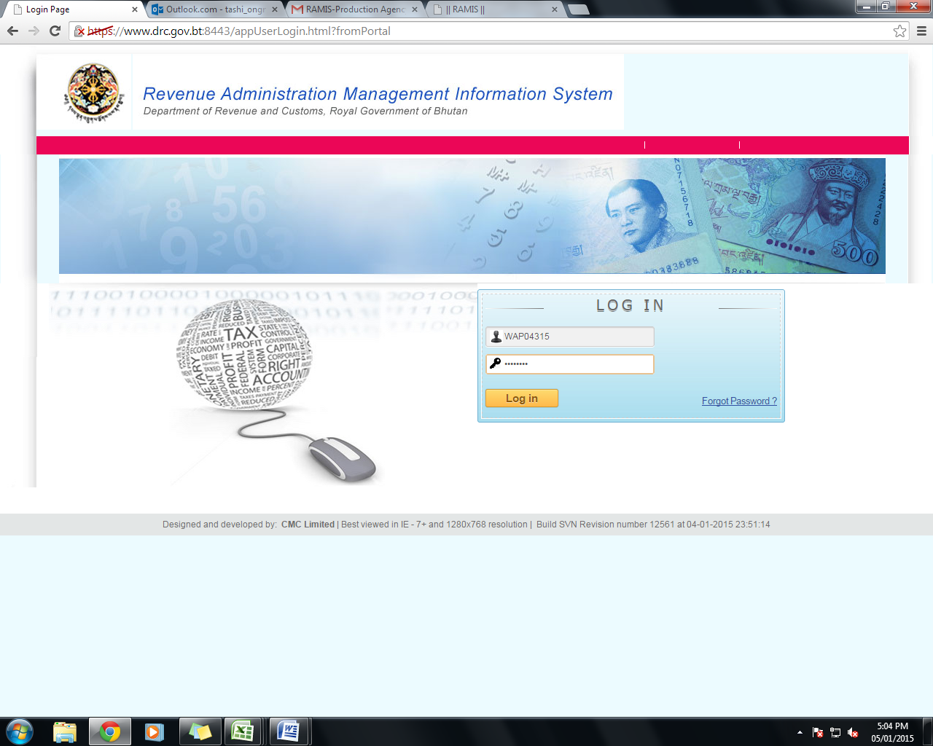

- In the initial login, you will be prompted to change your password. 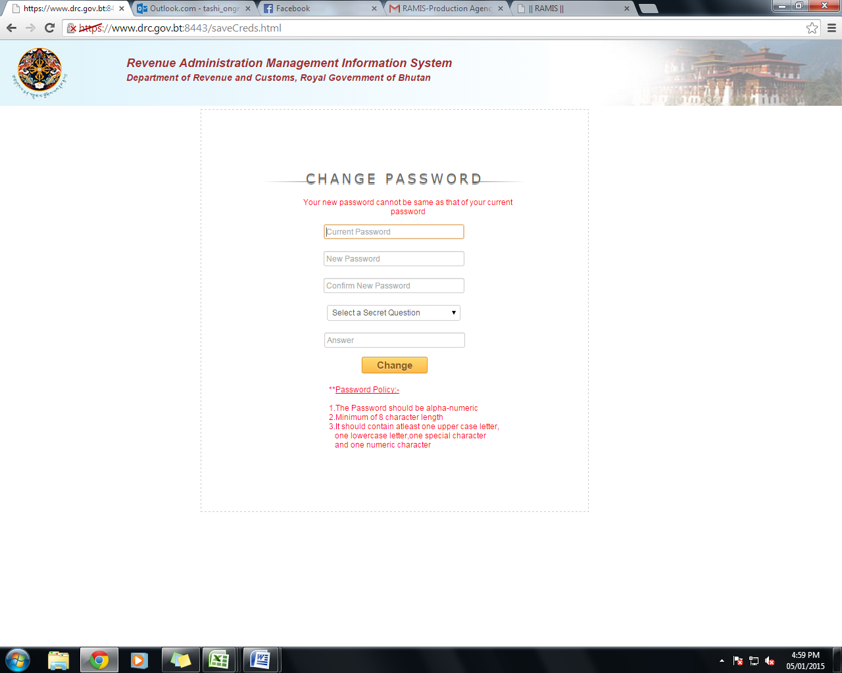

- After the changing the password, you need to re-login using the TPN as your user ID. The following page will be displayed.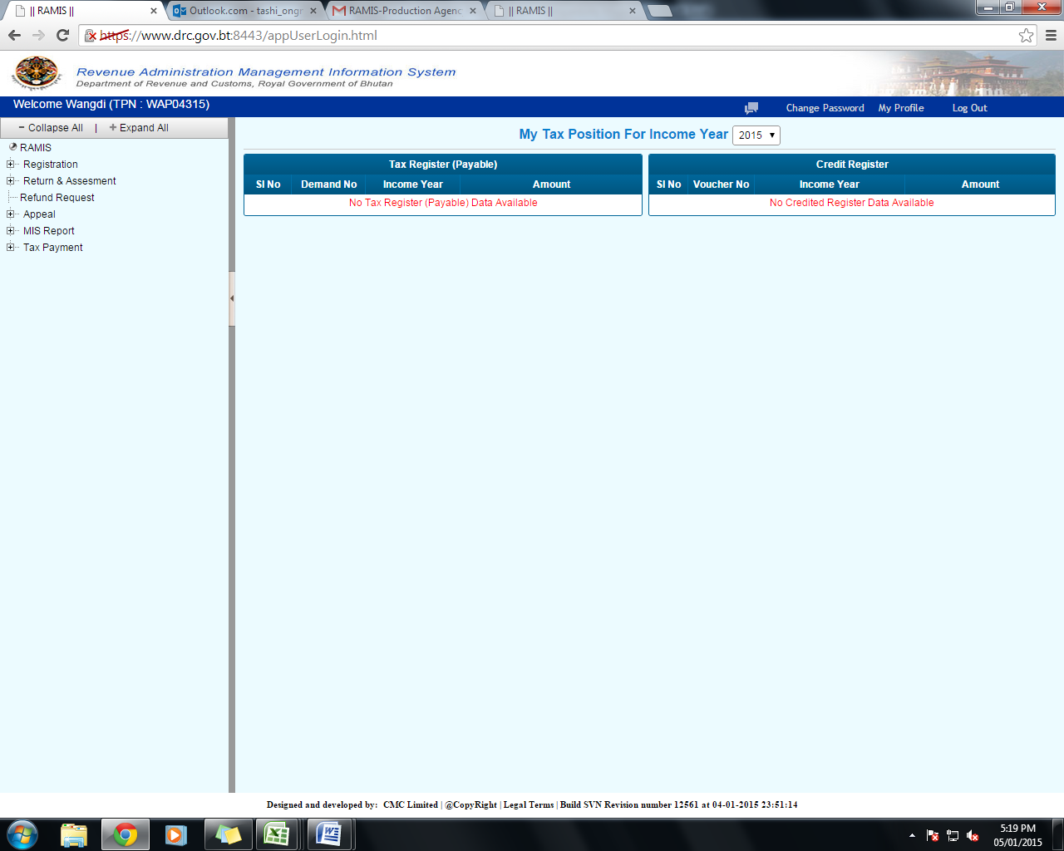

- Click on ‘My Profile’ to update all your details. Against each of the details, there is an option to ‘edit’. Click on edit and provide all information. In the general details, it is mandatory to provide either of email address or mobile no. 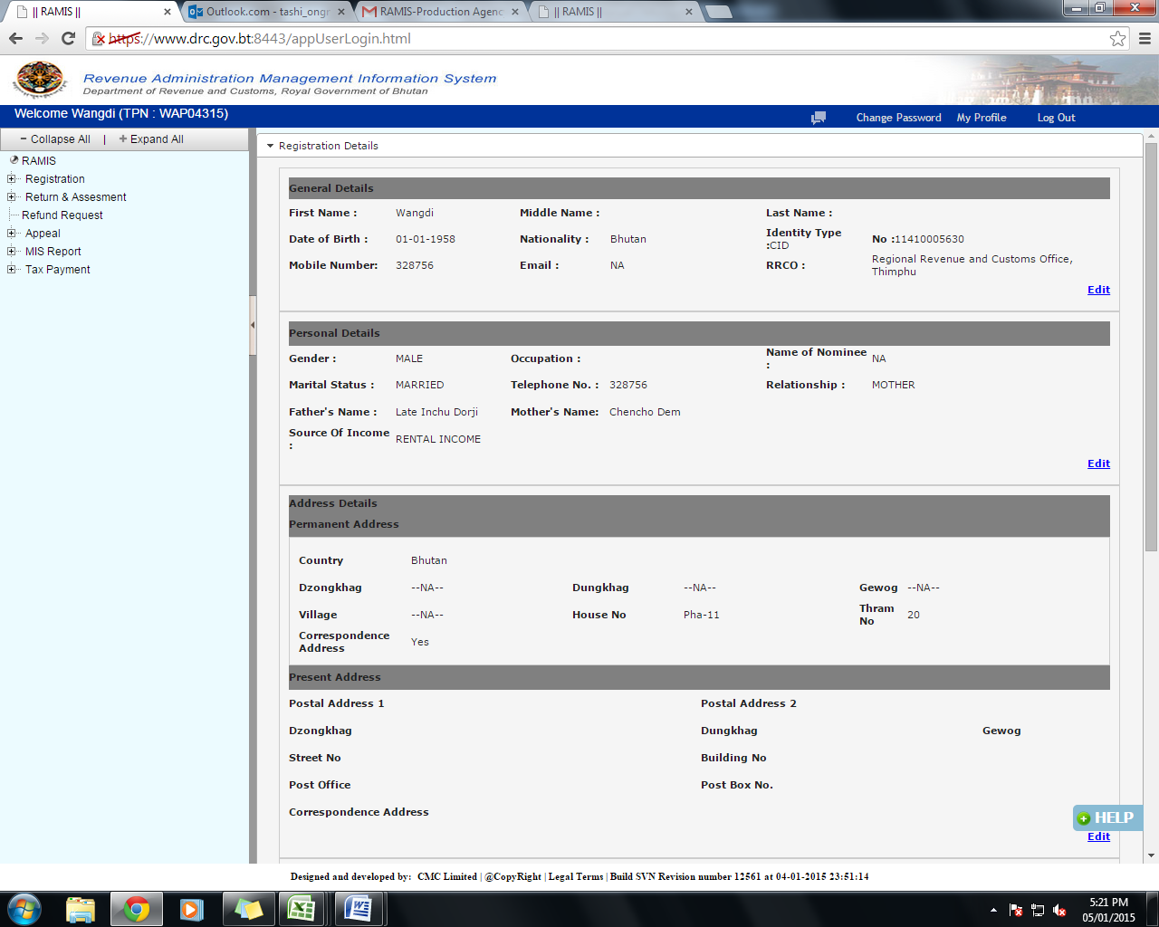

- For claiming educations expenses, child detail is mandatory. Bank details of the taxpayer are also mandatory.
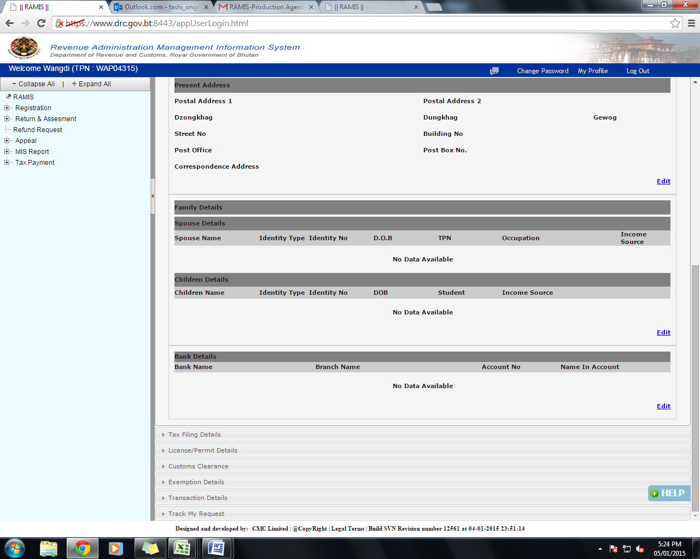

- Update all the details; check (tick) the disclaimer note and click on ‘save’.
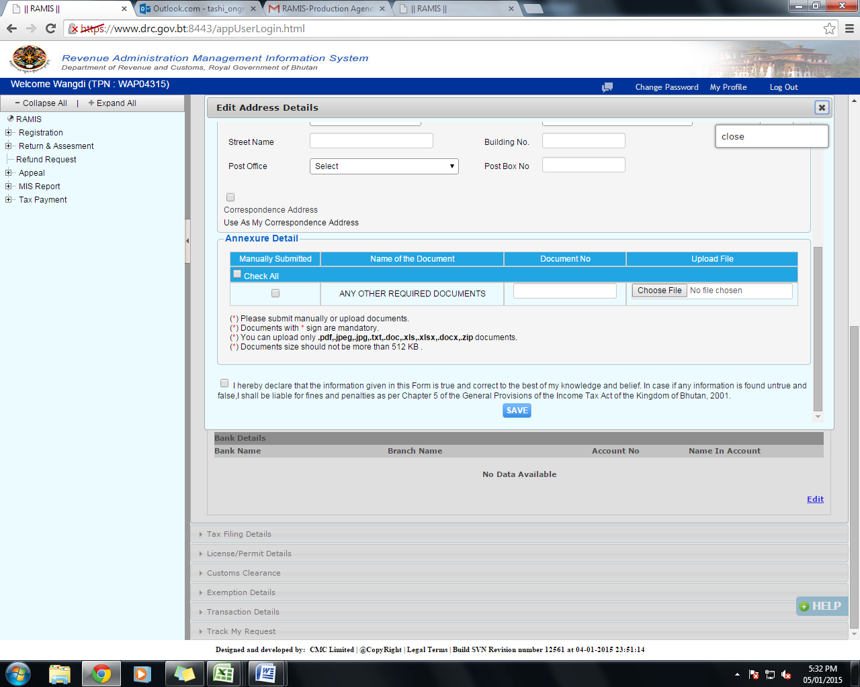

- A message will be generated after successfully submitting the document. An application reference no. (ARN) will also be generated. The same message will also be sent o your email address. 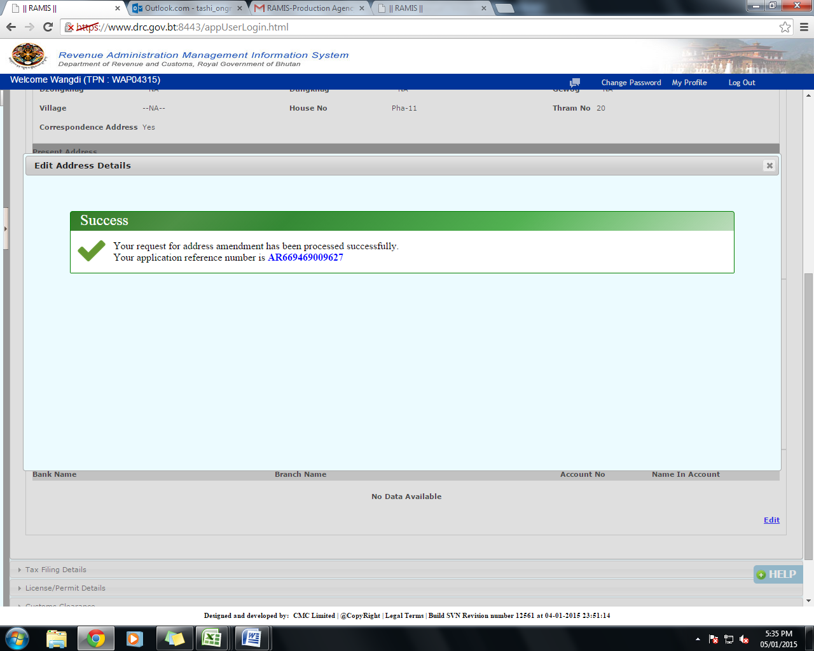

- You can track your any of your application with your ARN no.
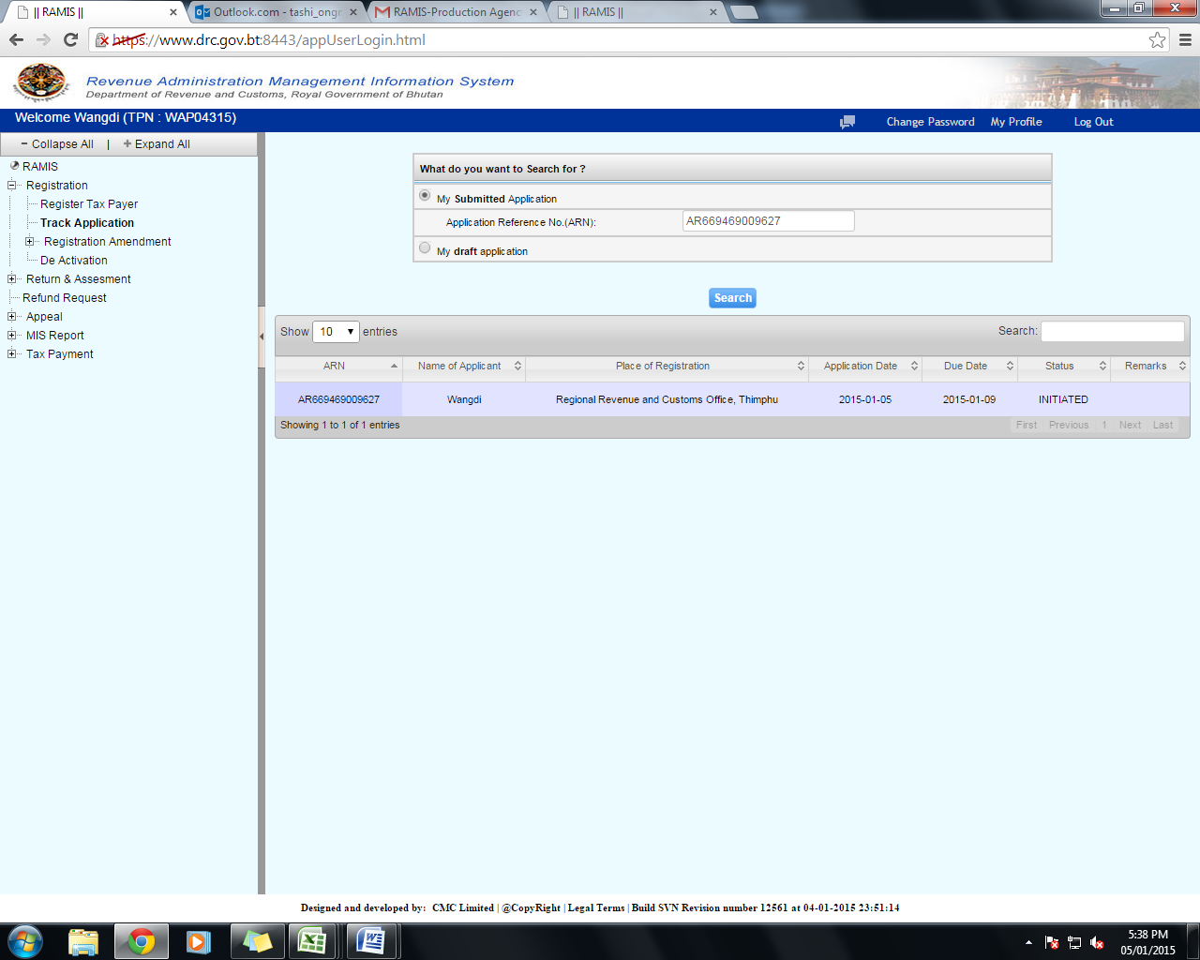

- Once your application is approved, you can file your tax return by clicking on ‘Return & Assessment’— Return Filing—File Return
