Copy of a Marriage Certificate Application Form

Please use this form to request copies of marriage certificates. Please provide as much information as you can, but questions marked in BOLD TYPE must be answered.

Applicant Details

NAME
ADDRESS
POSTCODE
CONTACT PHONE NUMBER
Email Address

Details of Marriage Certificate Required

Groom
Forename(s)
Surname
Any other names known by

Bride
Forename(s)
Surname before marriage
Any other names known by
Date of marriage
Place of marriage | (name of building, church or register office and locality)

Additional Details
Number of copies required |  | Cost per certificate | £10.00
Total enclosed

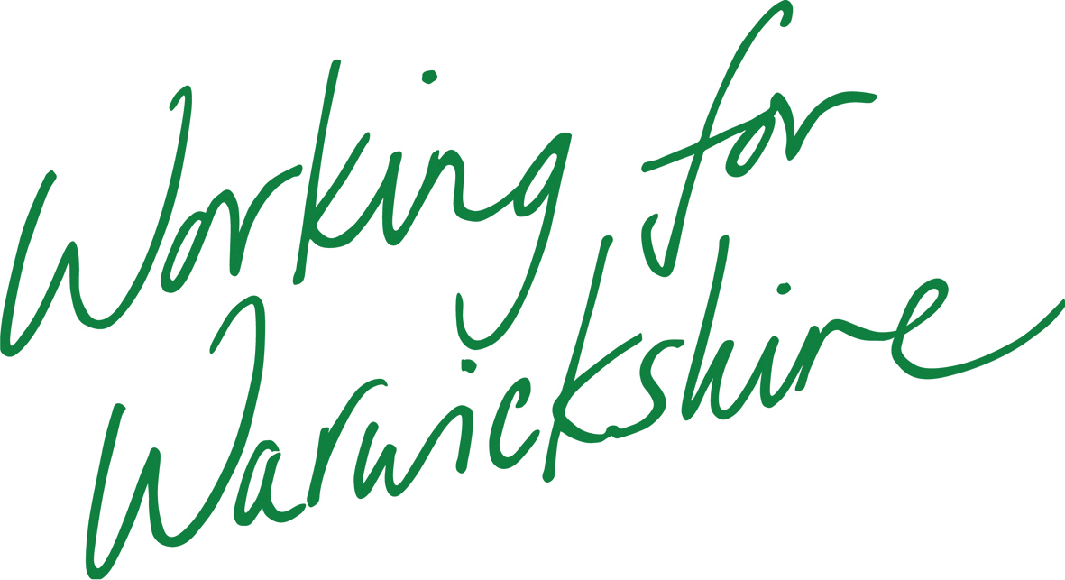

Please send this completed form, along with a cheque/postal order made payable to Warwickshire County Council for the total amount and a stamped, self addressed envelope to the appropriate register office:

Rugby:  The Register Office  5, Bloxam Place  Rugby  CV21 3DS | Nuneaton:  The Register Office  Riversley Park  Coton Road  Nuneaton  CV11 5HA | Warwick:  The Register Office  PO Box 9  Shire Hall  Warwick  CV34 4RR

