Copy of a Birth Certificate Application Form

Please use this form to request copies of birth certificates. Please provide as much information as you can, but questions marked in BOLD TYPE must be answered.

Applicant Details
your full NAME
your postal ADDRESS
POSTCODE
CONTACT PHONE NUMBER
Email Address

Details of Birth Certificate Required

Full name at birth
Forename(s)
Surname
Date of Birth
Place of birth | (full address or name of hospital)

Father’s Details
Forename(s)
Surname

Mother’s Details
Forename(s)
Surname
Maiden surname

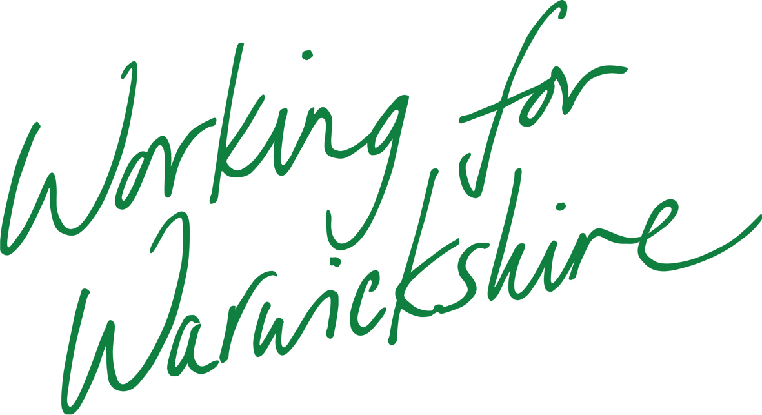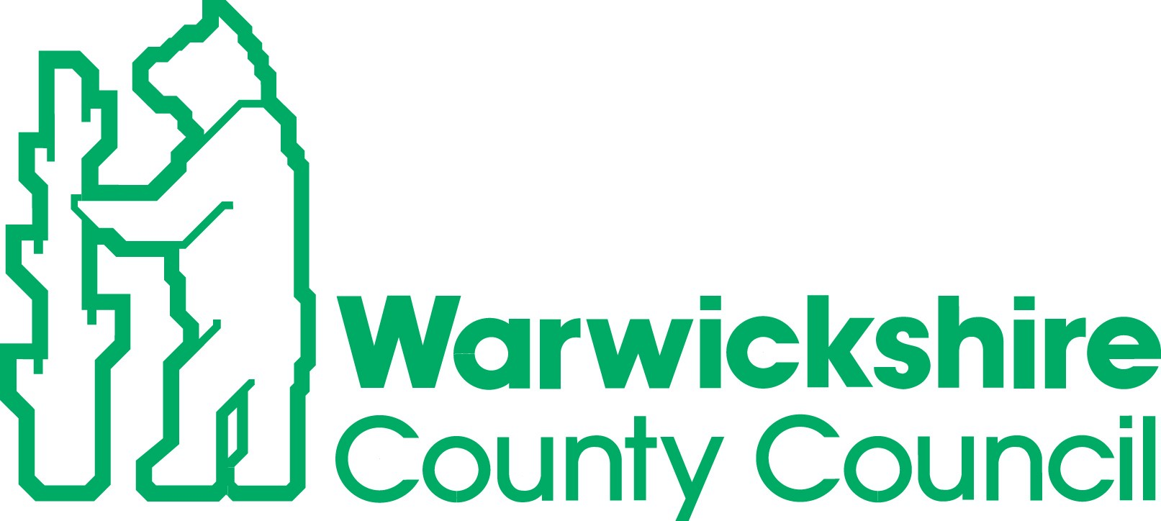

Additional Details
There are two types of birth certificate available.

Standard certificates are a full copy of the birth entry and include particulars of parentage and registration.

Short certificates only show the name, sex, date of birth and district of birth

A Standard certificate is required when applying for official documents such as passports and driving licences.

Number of Standard certificates required |  |  | Cost per certificate | £10.00
Number of Short certificates required |  |  | Cost per certificate | £10.00
Total enclosed

Please send this completed form, along with a cheque/postal order made payable to Warwickshire County Council for the total amount and a stamped, self addressed envelope to the relevant register office:

Rugby:  The Register Office  5, Bloxam Place  Rugby  CV21 3DS | Nuneaton:  The Register Office  Riversley Park  Coton Road  Nuneaton  CV11 5HA | Warwick:  The Register Office  PO Box 9  Shire Hall  Warwick  CV34 4RR

